

V 1.0
May 2026

XStep Design Specification
SMPL: Theoretical No. of Vials

Table of Contents
Right-click and choose Update Field to build the table of contents.

Purpose
The document details the functional design, along with the configuration specifications for the XStep “SMPL: Theoretical No. of Vials”. The process step uses the Viable Cell Density along with the Culture volume to determine the approximate number of vials that the flask will yield.

Overview
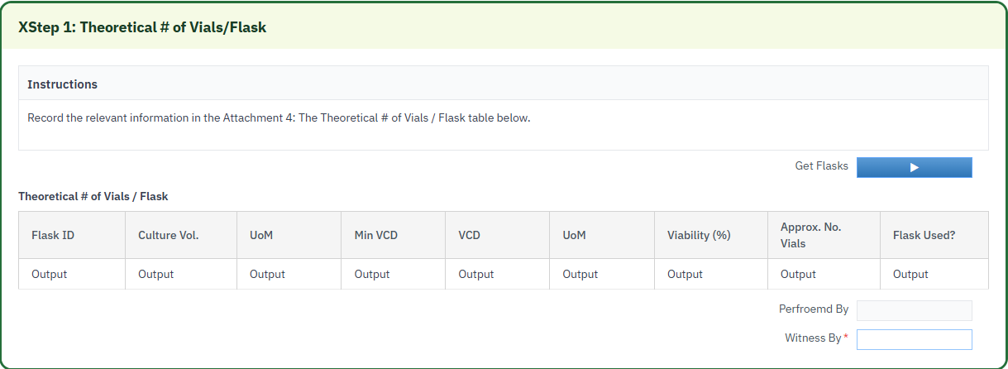
The Xstep will have a function linked to a button labeled “Get Flasks” that will retrieve the Flask ID, Culture Vol, VCD and VIability % from the ZTC_FLASK_DETAILS table for the order.
The table will contain the following fields.
- Flask ID - Output: This value will populate based on the “Get Flasks” button press from the ZTC_FLASK_DETAILS table
- Culture Vol. - Output: This value will populate based on the “Get Flasks” button press from the ZTC_FLASK_DETAIL table
- UoM - Output: Defaulted to mL
- Min Vcd - Output: This value is configured through an Input parameter that will be configured in MBR
- VCD - Output: This value will populate based on the “Get Flasks” button press from the ZTC_FLASK_DETAILS table
- UoM - Output: Defaulted to 10^8 cells/mL
- Viability (%) - Output: This value will populate based on the “Get Flasks” button press from the ZTC_FLASK_DETAILS table
- Approx. No. Vials - Output: Calculated with the formula “( Culture Vol (mL) * VCD (10^6 cells/mL) ) / 30 (10^6) “
- Flasks Used? - Output: Use a new function, ZSMPL_FM_COMPARE_VALUES_YES_NO to compare the VCD and Min VCD. Set results to yes if VCD is greater than Min VCD otherwise set to No.

Reasons for developing
The SMPL: Theoretical No. of Vials Xstep was developed to standardize and streamline the operations used to determine the number of vials a shaker flask can yield while also verifying that the minimum VCD has been met to proceed

Authorization
The Signature Strategies SS000201 - SiMPL Done By and SS000202 - SiMPL Checked By are created and assigned to the Authorization Groups AGDS0001 PI step Done By SS and AGDS0002 PI step Checked By SS. This ensures that at least two users are required to successfully sign off the process step. The first user signs off in the Performed By field and a second user signs the Witnessed By field.

Assumptions/ Dependencies
 | Assumption
1 | A validation is executed on the calculation output field to determine the correction type required based on the pre-defined validation rules. The correction type is automatically populated based on the validation result.
2 | The signature strategies and authorization groups are configured and linked appropriately. See Section 8 for reference.
3 | The information captured in SMPL: Cell Culture / Medium Addition and SMPL: Cell Count Log will be present in the z-table to retrieve from before execution of this step

Validation Checks
Error Handling
Error | Action
User is signed into the PI sheet | Validation popup
Witnessed by is not the same as the performed by user | Validation popup

XStep Layout Design


Function Module(s)
Function: ZSMPL_FM_GET_FLASKS
Import Parameters:
Parameter Name | Associated Type | Short Text
IV_AUFNR | AUFNR | Order Number
IV_MIN | ERFMG | Minimum VCD (optional)

Export Parameters:
Parameter Name | Associated Type | Short Text
ET_FL_ID | /SMPL/STR_TT_CHAR30 | Flask number
ET_CU_VOL | /SMPL/STR_TT_ERFMG | Flask / culture quantity
ET_VCD | /SMPL/STR_TT_ERFMG | Viable cell density
ET_VIS | /SMPL/STR_TT_CHAR30 | Viability %
ET_CU_UOM | /SMPL/STR_TT_CHAR30 | Quantity unit of measure
ET_USED | /SMPL/STR_TT_CHAR30 | Used indicator (Yes/No)

Exceptions:
Exception | Short Text
FLASK_NOT_FOUND | No flask records found for the order

Function: /SMPL/PPPI_FM_INITIAL_ACTIVE
Import Parameters:
Parameter Name | Associated Type | Short Text
IV_ACTIVE | CHAR1 | N/A

Export Parameters:
Parameter Name | Associated Type | Short Text
EV_ACTIVE | CHAR1 | N/A

Function: /SMPL/MBR_DEP_CHECK_ACTIVE
Import Parameters:
Parameter Name | Associated Type | Short Text
IM_CONTROL_RECIPE | POC_DOCID | N/A
IM_PHASE | VORNR
IM_AUFNR | AUFNR
IM_STEP_UUID | /SMPL/MBR_SOG_UUID
IM_PLANT | WERKS_D

Export Parameters:
Parameter Name | Associated Type | Short Text
EV_ACTIVE | CHAR1 | N/A

Exceptions:
Exception | Short Text
CONTROL_RECIPE_INITIAL

Pseudocode
Function: ZSMPL_FM_GET_FLASKS
1. Purpose
Reads the most recent cell-count flask data for an order and returns each flask’s details, flagging whether the flask is usable based on a minimum VCD.
2. Input Parameters
• IV_AUFNR – process order whose flask data is read.
• IV_MIN – minimum VCD a flask must reach to be marked as usable.
3. Processing Logic
a. Read the latest production day (MAX prod_day) from ZTC_FLASK_DETAIL for IV_AUFNR; if none exists, raise FLASK_NOT_FOUND.
b. Select all flask rows for that order and production day; raise FLASK_NOT_FOUND if none are returned.
c. For each flask, output the flask number, quantity, VCD, viability % and unit of measure.
d. Mark ET_USED "No" when the flask’s VCD is below IV_MIN, otherwise "Yes".
Output
• ET_FL_ID / ET_CU_VOL / ET_VCD / ET_VIS / ET_CU_UOM – per-flask number, quantity, VCD, viability and UoM.
• ET_USED – per-flask usable indicator (Yes/No).
Additional Notes
Error Handling:
• FLASK_NOT_FOUND – no flask data exists for the order / latest production day.
Dependencies:
• Table ZTC_FLASK_DETAIL.
Assumptions:
• The cell-count log is populated for the order; the latest production day holds the flasks to evaluate.

Function: /SMPL/PPPI_FM_INITIAL_ACTIVE
1. Initialization
a. Input parameter IV_ACTIVE is optionally provided by the calling logic.
b. Constants gc_yes, gc_no, and gc_inside_range are assumed to be defined globally in the context of the function module.
2. Active Flag Evaluation
a. The function checks if the input value IV_ACTIVE falls within the expected valid range, represented by gc_inside_range.
b. Based on the result:
• If the input value is not equal to gc_inside_range, the XStep is marked as inactive by setting EV_ACTIVE = gc_no.
• If the input value is equal to gc_inside_range, the XStep is marked as active by setting EV_ACTIVE = gc_yes.
3. Output Assignment
a. The evaluated result is returned in the EV_ACTIVE export parameter for use by the calling logic (e.g., XStep configuration, PI sheet rendering).
Additional Notes
• This is a simple normalization function that abstracts how activation flags are interpreted for PPPI XSteps.
• The use of constants (gc_yes, gc_no, gc_inside_range) aligns the logic with broader application settings or standards.
• Input is optional, so defaulting behavior can be configured outside this function.

Function: /SMPL/MBR_DEP_CHECK_ACTIVE
1. Initialization
a. Input parameters provide context for determining whether an MBR step can be activated:
• IM_CONTROL_RECIPE (POC_DOCID) – Control recipe ID identifying the batch instruction.
• IM_PHASE (VORNR) (Optional) – Operation or phase within the process order.
• IM_AUFNR (AUFNR) (Optional) – Process order number associated with the step.
• IM_STEP_UUID (/SMPL/MBR_SOG_UUID) – Unique step identifier (SOG).
• IM_PLANT (WERKS_D) – Plant code for process context.
b. The function validates that IM_CONTROL_RECIPE is not initial; if it is, CONTROL_RECIPE_INITIAL is raised. Internal data is initialized and routine LOAD_INTERNAL_DATA populates the order dependency buffers.
2. Signature Data Retrieval
a. Signature records for the process order are retrieved from /SMPL/MBR_OR_SIG (AUFNR = IM_AUFNR) into internal table lt_ord_sigs for evaluation.
3. Dependency Evaluation
a. The function loops through dependencies where TARGET_UUID = IM_STEP_UUID and DEP_RULE is a Perform-Before-Start or Verify-Before-Start rule:
• For PERFORM BEFORE START, it checks whether the prerequisite step has a pending perform signature.
• For VERIFY BEFORE START, it checks whether the prerequisite step has a pending verify signature.
b. If an incomplete signature is found, the step is marked inactive (EV_ACTIVE = gc_step_inactive); if all prerequisites are complete, it is marked active (EV_ACTIVE = gc_step_active).
4. Output Assignment
a. The evaluated activation status is returned in EV_ACTIVE (active = all prerequisites complete; inactive = at least one prerequisite incomplete).
Additional Notes
• Evaluates Perform Before Start and Verify Before Start dependency rules using live signature data from /SMPL/MBR_OR_SIG.
• Error Handling: raises CONTROL_RECIPE_INITIAL if the control recipe is missing; handles empty dependency/signature data without runtime errors.
• Activation status is recalculated each time the function is called to reflect live signature data.

Configuration Specifications
A z-table will be created, ZTC_FLASK_DETAILS to store the total added amount for each flask. The z-table will contain the following fields.
- MANDT - MANDT: Client, key field
- AUFNR - AUFNR: Order number, Key field
- FLASK_NUM - CHAR30: Flask number. Key Field
- VCD - /SMPL/STR_DE_ONE_DEC: Viable Cell Density
- VIABILITY_PCT - INT1: Viability percentage
- FLASK_QTY - ERFMG: Total quantity of flask
- FLASK_UOM - CHAR15: UoM of the flask quantity if taken in g or mL

Test Scenarios
Disclaimer: The test scenarios outlined below are primarily authored by developers and architects to validate technical specifications. Each scenario is to be assigned a test ID by a Business Analyst, ensuring consistency and ease of tractability throughout the project.

# | Scenario | Type | Expected Result | Actual Result | Pass/ Fail
1 | Create and Release a Process Order with the pre-configured SiMPL Master Recipe and the relevant Production Version | Positive | Process Order created and Released containing SMPL: Cell Culture / Medium Addition
2 | Open the EBR and navigate to SMPL: Theoretical No. of Vials | Positive | The EBR for the selected Process Order and Control Recipe opens successfully without any errors and the SMPL: Cell Culture / Medium Addition step is visible
3 | Select “Get Flasks” |  | -Table values populate correctly
 | Sign the performed by signature |  | -Process sted completed
 | Sign the witnessed by signature |  | -Process sted completed

Document References
Reference No. | Document Title
Number used in superscript for reference | Full name of referenced document
1 | SiMPL Functional Guide: Universal Concepts

Revision History
Version No. | Description | Author | Date
1.0 | Initial Document | Tom Rautenbach | 22MAY2026

